Customer Shopping Behaviour Analysis

1. Project Overview:
The main goal of this project is to use transactional data to analyse consumer purchasing behaviour. The analysis's objectives are to find trends in consumer behaviour, comprehend consumer preferences, and offer information that can assist companies in enhancing their marketing plans and client interactions.

2.Dataset Summary:
The dataset contains data about consumer purchases and behaviour. Important features of the dataset include:
- Rows: 3,900
- Columns: 18
- Key Features:
- Customer demographics (Age, Gender, Location, Subscription Status)
- Purchase details (Item Purchased, Category, Purchase Amount, Season, Size, Colour)
- Shopping behaviour (Discount Applied, Promo Code Used, Previous Purchases, Frequency of Purchases, Review Rating, Shipping Type)
- Missing Data: 37 values in Review Rating column
This information offers a solid basis for analysing consumer purchasing patterns.

3.Exploratory Data Analysis using Python:
To ensure accuracy, the dataset was cleaned and prepared before analysis.
- Data Loading for data analysis and manipulation, the dataset was imported using Python (Pandas).
- Initial Data Exploration An initial investigation was carried out to comprehend Dataset arrangement, Data Types, Handling Missing Values Overview statistics, Missing values. Used df.info() to Check Structure and .describe() for summary statistics.
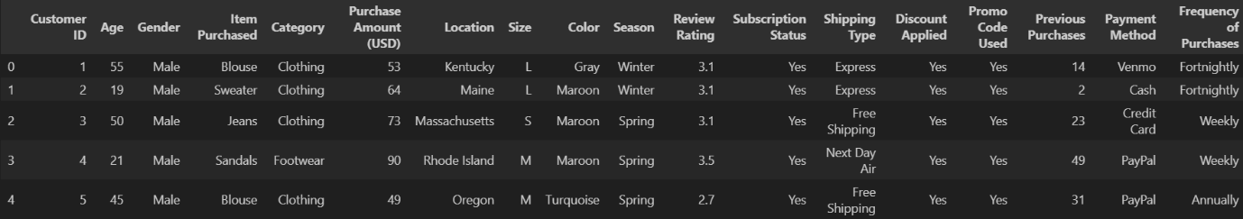
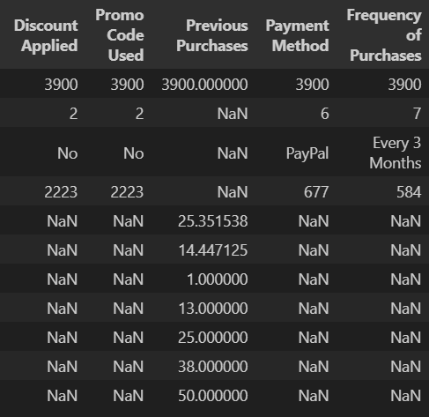

- Handling Missing Values: The Review Rating column contained 37 missing values. These values were filled using the median rating, which helps maintain the distribution of the data.
- Column Standardization: For improved readability and documentation, columns were renamed in snake case.
- Feature Engineering:
- Created age_group column by binning customer ages.
- Created purchase_frequency_days column from purchase data.

- Data Consistency Check: Promo_code_used was dropped after it was confirmed that discount_applied and promo_code_used were redundant.
- Database Integration: The cleaned Data Frame was loaded into the database for SQL analysis after a Python script was connected to MSSQL.

4. Data Analysis using SQL (Business Transactions):
We performed structured analysis in PostgreSQL to answer key business questions:
- Revenue by Gender – Compared total revenue generated by male vs. female customers.
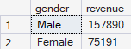

- High-Spending Discount Users – Identified customers who used discounts but still spent above the average purchase amount.

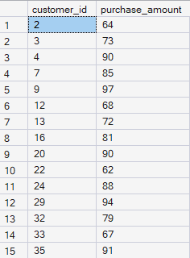

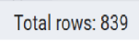

- Top 5 Products by Rating – Found products with the highest average review ratings.
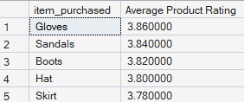

- Shipping Type Comparison – Compared average purchase amounts between Standard and Express shipping.
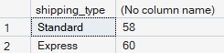

- Subscribers vs. Non-Subscribers – Compared average spend and total revenue across subscription status.
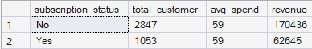

- Discount-Dependent Products – Identified 5 products with the highest percentage of discounted purchases.

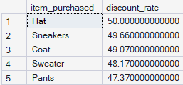

- Customer Segmentation – Classified customers into New, Returning, and Loyal segments based on purchase history.
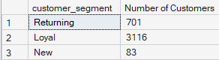

- Top 3 Products per Category – Listed the most purchased products within each category.

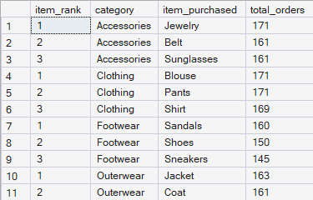

- Repeat Buyers & Subscriptions – Checked whether customers with >5 purchases are more likely to subscribe.

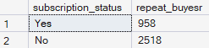

- Revenue by Age Group – Calculated total revenue contribution of each age group.

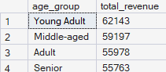

5. Dashboard in Power BI:
Finally, we built an interactive dashboard in Power BI to present insights visually.

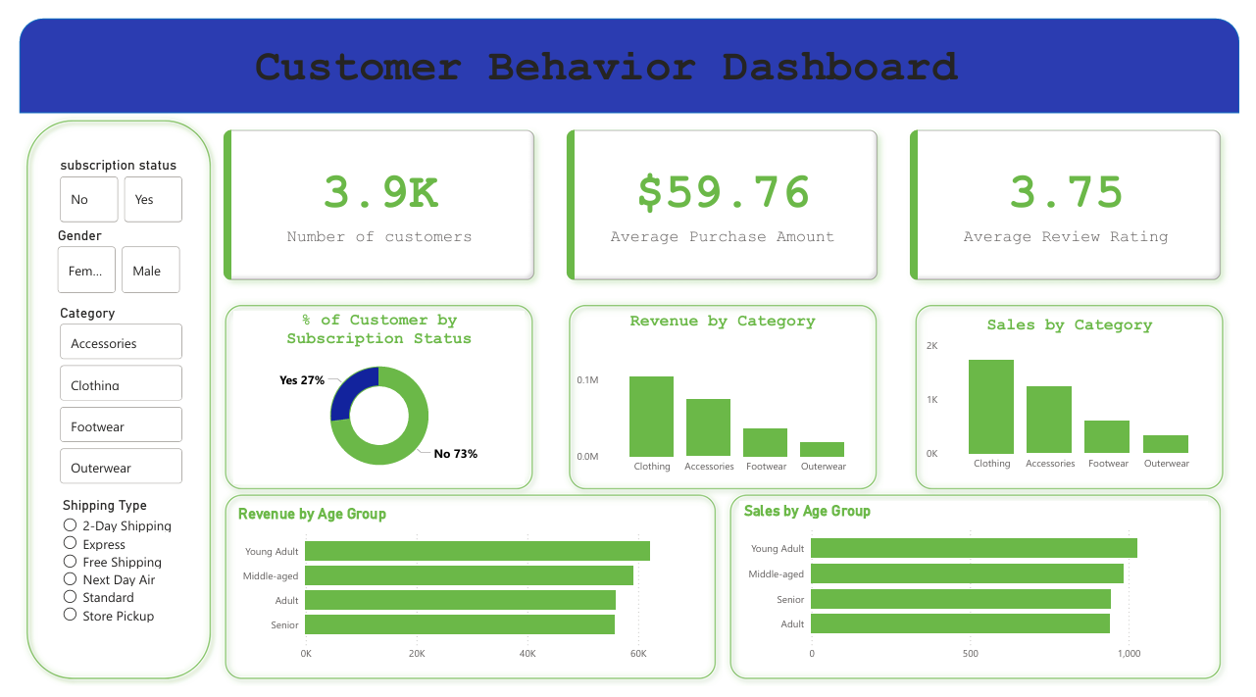

6. Business Recommendations:
- Boost Subscriptions – Promote exclusive benefits for subscribers.
- Customer Loyalty Programs – Reward repeat buyers to move them into the “Loyal” segment.
- Review Discount Policy – Balance sales boosts with margin control.
- Product Positioning – Highlight top-rated and best-selling products in campaigns.
- Targeted Marketing – Focus efforts on high-revenue age groups and express-shipping users.

